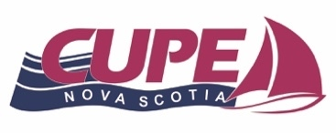
CUPE NOVA SCOTIA
Barbara Kowalski
2026 Literacy Award

CUPE Nova Scotia is seeking nominations for individuals or locals that have promoted literacy within their union, workplace and or community. There are two awards available annually: one for an individual member and one for a Local Union.

If you know a CUPE member or Local Union that champions workplace literacy programs please consider nominating them for this award. Nominations must be in by June 15th, 2026. CUPE Nova Scotia will present its Annual Provincial Literacy Award for an individual and Local Union at the 2026 Provincial Convention.
Award Criteria: Nominees must have actively promoted literacy programs within CUPE, and or their workplace and or their community and championed clear language by:

- Raising awareness on literacy and clear language within the Union and workplace.
- Help build the Union through literacy and clear language.
- Helped or led the development of a literacy program within their union/local or workplace or they may have promoted worker education in some other way.
- The Local Union must have participated in a literacy program and helped build a Union-centred education program in the workplace, or they may have promoted worker education in some other way.

Decisions of the CUPE Nova Scotia Awards Committee will be final. CUPE Nova Scotia assumes no responsibility for applications that are lost, misdirected, or otherwise not received by the deadline. Late submissions will not be considered.

To nominate an individual and/or a Local Union, please complete the nomination form for this award and upload it via Google Forms. Remember to clearly communicate in approximately one hundred (100) words why you feel the CUPE Member or local are a literacy champion.

Any questions please contact:
Nelson Scott, Awards Committee Chair
Email: vicepresident@cupens.ca
Mailing Address: 271 Brownlow Ave, Dartmouth, NS B3B 1W6 Attention: Nelson Scott

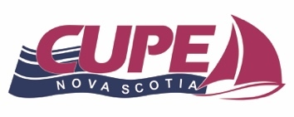
CUPE NOVA SCOTIA
Barbara Kowalski Annual Literacy Award
2026 Nomination Form

The name and contact Information of the Individual or Local Union you are nominating:

Name: Local Union Number:

Mailing Address:

Telephone - Day: Evening:

E-Mail: Years as a CUPE Member:

Occupation:

The name of the person nominating with contact information:

Name: Local Union Number:

Mailing Address:

Telephone - Day: Evening:

E-Mail:

This nomination is supported by local/Division:

Signature of Local President’s Please Print Name

And/or

Signature of Local or Division Executive Member Please Print Name

What do we mean by “Literacy”?
Literacy is the ability to read, write, work with numbers, problem solve, communicate and think critically at whatever level is basic to the task at hand. Literacy empowers us to:
- assert our rights and build our Union
- act as full citizens and change society
- question, evaluate, and envision
- develop our knowledge and potential at work, at home, and in our community
What is “Clear Language”?
- language that readers can understand
- design that makes documents easy to read and easy to use

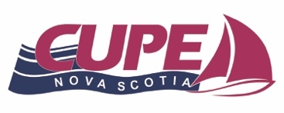
CUPE NOVA SCOTIA
Barbara Kowalski Annual Literacy Award Nomination Form

Please share why you are nominating this member or Local Union for the CUPE Nova Scotia Literacy Award and how they have promoted literacy within CUPE, their workplace and or their community.

How has the member or Local Union influenced literacy with other members and the Union?

Please describe how the member or Local Union has helped strengthen the Union through their literacy and clear language activism?

List literacy programs that the member or Local Union has helped to develop or led within CUPE, their workplace and or their community.
(if you are nominating a group of members, please list each person)

