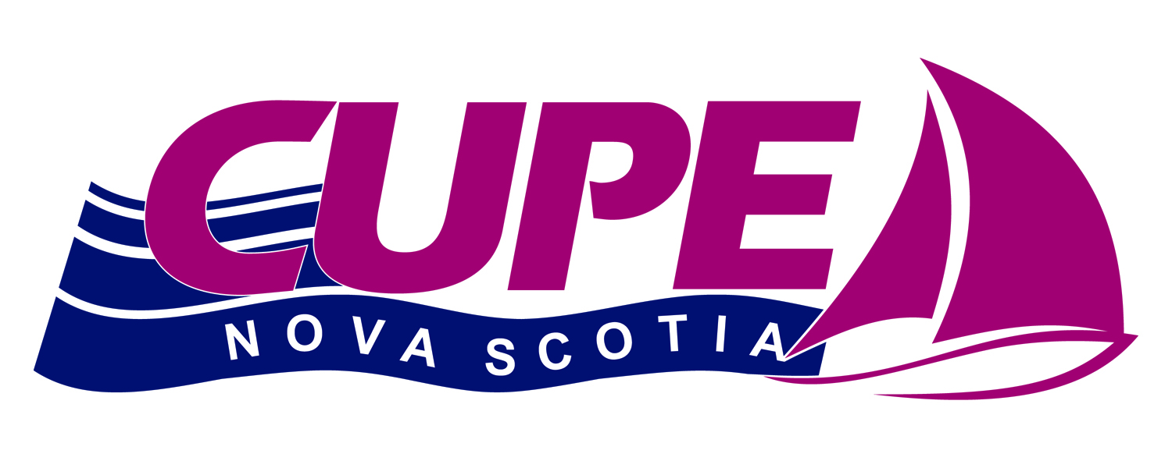
CUPE NOVA SCOTIA
2026 Rocky Jones Bursary

CUPE Nova Scotia awards one $1,000.00 Rocky Jones Bursary annually for the upcoming academic year.

Eligibility: 1. A student that is an African Nova Scotian or an Indigenous Nova Scotian.
2. Applicant must be graduating or have graduated from a Nova Scotia High School and entering their first year of post-secondary education.
3. Applicant must be a member, child of, or legal ward of a member in good standing of a local union affiliated to CUPE Nova Scotia.
4. Consideration will be given to first time recipients.
Application must be complete and on the application form and must be received no later than April 15, 2026. Please note that only the winning applicant will be notified. We thank all applicants for their interest.
Decisions of the CUPE Nova Scotia Awards Committee will be final. CUPE Nova Scotia assumes no responsibility for applications lost, misdirected, or otherwise not received by the deadline. It is the applicant's sole responsibility to ensure that the application is made correctly, legibly and received by the deadline date.
Confidentiality: Member data is highly confidential and must be treated as such. CUPE Nova Scotia will at all times keep confidential the affairs of the membership. The names of the successful applicants may be published in official publications and/or web site of CUPE Nova Scotia.
The Applications MUST be completed and mailed to the CUPE ARO at the address below. Late applications will not be considered.

Any questions please contact:
Nelson Scott, Awards Committee Chair
Email: vicepresident@cupens.ca
Mailing Address: 271 Brownlow Ave, Dartmouth, NS B3B 1W6 Attention: Nelson Scott

CUPE Nova Scotia

2026 Rocky Jones Bursary
APPLICATION FORM
- Name of Applicant:

___________________________________________________________________________
Last Name First Name Middle Initial

- Address:

___________________________________________________________________________
Street and Number City/Town Province Postal Code

- Telephone Number and email:

___________________________________________________________________________
Home Work Other

___________________________________________________________________________
Email

- Name of Guardian if applicant is a dependent or ward:

___________________________________________________________________________
Last Name First Name Middle Initial

- Sector and Classification:

___________________________________________________________________________

- Name of CUPE Local:

___________________________________________________________________________

- Name of Post-Secondary Institution you will be attending, name of degree or diploma and what year you are entering.

___________________________________________________________________________
___________________________________________________________________________

8. List volunteer community organizations, cultural and/or student activities or athletics
you are involved in.
___________________________________________________________________________

___________________________________________________________________________
___________________________________________________________________________
___________________________________________________________________________
___________________________________________________________________________

9. One of the following must be submitted with the completed application form:
A written essay explaining why you are interested in obtaining this Bursary and explaining how Dr. Jones’ activism inspires your future plan of study.

OR

A YouTube video, infographic, visual art or song on the topic noted above. Songs must be submitted via audio file with your name in the file.

10. A letter of reference from a Principal, Counselor, student support worker, or community
member must be submitted with this application.

11. I am an African Nova Scotian Student YES _____ NO _____

I am an Indigenous Nova Scotian Student YES _____ NO _____

I certify that the foregoing statements and information is complete to the best of my knowledge and hereby give authorization to CUPE Nova Scotia to verify any information given on this application and permission to publish my name and picture in their newsletter and website/social media.

Signature of Applicant: _____________________________________ Date:___________________

I certify that the foregoing statements and information is complete to the best of my knowledge and hereby give authorization to CUPE Nova Scotia to verify any information given on this application.

Signature of Applicant Guardian: ________________________________
Date: _________________

