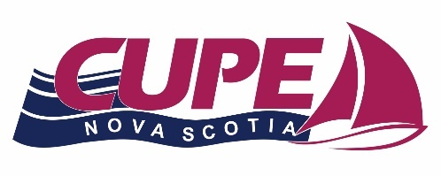
CUPE NOVA SCOTIA
MIKE MCNEIL
WEEKLONG SCHOOL SCHOLARSHIP 2026

The CUPE Nova Scotia Mike McNeil Weeklong School Scholarship is awarded by CUPE Nova Scotia annually. The Scholarship will cover the full cost for the purpose of attending the CUPE Atlantic Weeklong School.

Eligibility:
Nova Scotia CUPE Union Locals may submit the name of a member for this scholarship. The member must be in good standing with their local and the submitting local must be affiliated to CUPE Nova Scotia. Preference will be given to a local and member who has not previously received a scholarship for the weeklong school and who would otherwise be unable to send a member to the weeklong school due to finances.
Decisions:
The decision of the CUPE Nova Scotia Awards Committee will be final. CUPE Nova Scotia assumes no responsibility for applications or supporting documents lost, misdirected, or otherwise not received by the deadline. It is the applicant's sole responsibility to ensure that the application is made correctly, legibly and received by the deadline date. Late submissions will not be considered.
Confidentiality:
Member data is highly confidential and must be treated as such. CUPE Nova Scotia will always keep confidential the affairs of the membership. The names of the successful applicant may be published in official publications and/or the web site of CUPE Nova Scotia.

Applications MUST be received no later than April 15th, 2026 and mailed to the CUPE ARO at the address below. No late applications will be considered.

All inquiries regarding the scholarship should be directed to:
Any questions please contact:
Nelson Scott, Awards Committee Chair
Email: vicepresident@cupens.ca
Mailing Address: 271 Brownlow Ave, Dartmouth, NS B3B 1W6 Attention: Nelson Scott


CUPE NOVA SCOTIA MIKE MCNEIL WEEKLONG SCHOOL

2026 SCHOLARSHIP

APPLICATION FORM

1. Name and Number of Submitting Local:

2. Name of Member registered to attend the Weeklong School:

Last Name First Name Middle Initial

3. Address:

Street and Number City/Town Province Postal Code

4. Telephone Number and email:

Home Work Cell

Email

5. Has your local attended the Atlantic Region Weeklong School in the past?
□ YES □ NO

6. Has your member or your local received the CUPE NS Weeklong School scholarship in the past?
□ YES □ NO

7. What benefit would be gained by your member and your local in participating in the Atlantic
Region Weeklong School?

8. Please submit the previous year's Trustees report outlining the financial position of your local.

I certify that the foregoing statements and information is complete to the best of my knowledge and hereby give authorization to CUPE Nova Scotia to verify any information given on this application.

Signature of Local President: __________________________ Date:
Signature of Applicant: ____________________ Date:

