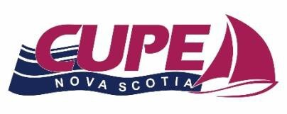
2026 Steward of the Year Award

CUPE Nova Scotia Executive Board is pleased to encourage affiliated Locals to nominate someone they feel deserving of the CUPE Nova Scotia Steward of the Year Award.

This Award will be presented at the CUPE Nova Scotia Annual Convention. Completed Nomination Forms MUST be received by April 15th, 2026 to be considered. No late nominations will be considered.

If you have a Steward who you believe to be a Champion Steward in your workplace. For examples a Champion Steward may include, but not be limited to, a Steward who:

- Encourages members to speak up for themselves with the Employer by educating members on their rights.

- Ensures that workplace issues are handled in accordance with the collective agreement.

- Raises awareness about the rights of workers in accordance with legislation; and
- Follows through on concerns during the grievance process, in a timely fashion and keeps members updated throughout the process.

To nominate a Steward from your Local please complete the attached CUPE Nova Scotia Steward of the Year Nomination Form and mail it to the CUPE ARO at the address below.

Any questions please contact:
Nelson Scott, Awards Committee Chair
Email: vicepresident@cupens.ca
Mailing Address: 271 Brownlow Ave, Dartmouth, NS B3B 1W6 Attention: Nelson Scott

REMEMBER: All completed nominations MUST be received by April 15th, 2026.

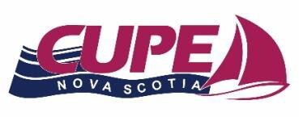
2026 Annual Steward of the Year Award
Nomination Form

Date: Local: Number:
- Name of Nominee:

Last Name First Name Middle Initial

- Address:

Street and Number City/Town Province Postal Code

- Telephone Number(s):

Home Work Cell Other

Email Address:

- Occupation:
- Years as a CUPE Member:
- Years as a Shop Steward:
- Please give a brief explanation of why you feel the Shop Steward you are nominating should be considered as Steward of the Year. If you need more space use the back of this sheet.

Signed:

Local Union President Local Union Recording Secretary
Print name: Print name:

NOTE: All completed nominations MUST be received by April 15th, 2026 to be considered. No late nominations will be considered so please ensure this form is received before the deadline.

